**PDPM INDIAN INSTITUTE OF INFORMATION TECHNOLOGY, DESIGN AND MANUFACTURING JABALPUR**

### Madhya Pradesh-482005, India



Early Detection of Heart Attack

*Interim Report II, submitted in partial fulfilment of the requirement for the degree of*

**Bachelor of Technology (B. Tech) and Bachelor of Design (B. Des)**

# Kushal Gaddamwar

(Roll no.-20BCS121)

# Raghav Patidar

(Roll no.-20BCS168)

# Neeraj Kumar

(Roll no.-20BCS144)

# Priyansh Sahu

(Roll no.-20BCS163)

# Katta Nitish

(Roll no.-20BEC052)

# Mehul Dehury

(Roll no.-20BDS052)

# Swastik Bharti

(Roll no.-20BSM058)

**Under Supervision of**

***Dr. Koushik Dutta***

AIM

Heart diseases and problem still remains one of the largest cause of deaths among adults and senior citizen. The uncertainty of a heart attack, stroke, or collapse is the biggest fear of a heart patient. Not getting primary medical support and assistance on time causes a lot of these death or permanent irreparable damages.

Our project tries to solve the uncertainty problem threw the help of AI and ML. A wearable portable device connected to your phone that can track your heart condition in real time and provide the data to your mobile and a database. This data will be continuously fed to an ML algorithm to detect any anomaly in your heart’s condition and detect if the person is having a heart attack. If a person is having a heart attack proper medical assistance will be provided to them and family and the doctor will be alerted.

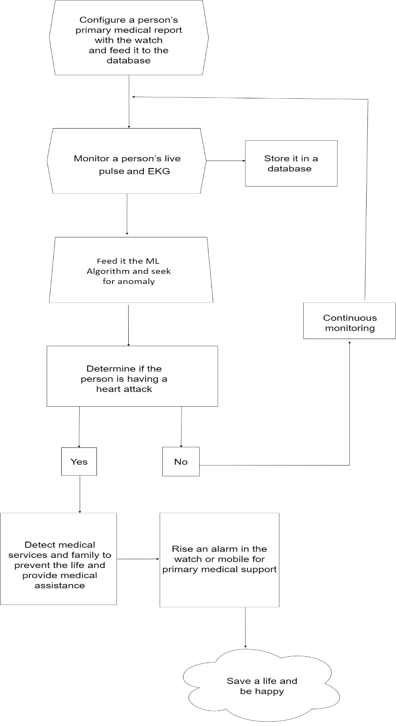

## Technical/Product Specification

Following sensors would be used in the device:

#### Pulse Sensor:

A pulse wave is the change in the volume of a blood vessel that occurs when the heart pumps blood, and a detector that monitors this volume change is called a pulse sensor.

#### Oximeter:

An instrument to measure the proportion of oxygenated hemoglobin in the blood.

#### Sweat Sensor:

Device to monitor the levels of sweating and substances in sweat.

#### Electrocardiogram:

A compact and wearable EKG, to detect the beating of heart.

* 1. **Gyroscope, Accelerometer, GPS tracking System:**

For tracking patient’s geolocation speed and positioning.

* 1. **LED Display, Speaker, Vibrator, Ambient Light sensors:**

Basic watch features.

* 1. **Arduino and Other components:**

For connecting and building a prototype.

* 1. **Motherboard:**

For developing a production level product.

## Concept Generation

The main objective of this fabrication project is to make a wearable and portable device, for people with heart disease and complications who has a higher risk of heart failure and/or stroke, to assist them in recovery and detect and prevent heart attack.

The concept is to gather the medical history of a patient along with their current time cardiovascular health with the help of oximeter and ECG in the device.

We are to analyze this data along with surveys of various other patients with similar health issue and predict if a person is at a risk of a heart attack with the help of machine learning algorithms and AI, as early as possible and alert the patient, his doctor and kin via a mobile alerting mechanism. The device will also help in assisting doctor to keep a real time medical history of a patient

**Summary and Future Development Prospect**

The next phase of our Engineering Design Project will be to create a prototype of how product functions and give a basic understanding to the stakeholder of the functionality of the product. This is the phase where we finalize the design, components and conduct testing in order to convert into tangible output.

BILL OF MATERIALS

|  |  |  |  |  |  |
| --- | --- | --- | --- | --- | --- |
| **S No.** | **Sensor** | **Price (₹)** | **Quantity** | **Total Price** | **Item Description and Justification** |
| 1. | Oximeter | 3200/- | 1 | 3200/- | To measure pulse and heartbeat |
| 2. | ECG | 9500/- | 1 | 9500/- | Electric voltage monitoring |
| 3. | Gyroscope/Accelerometer | 3500/- | 1 | 3500/- | To measure running speed |
| 4. | Ambient Light Sensors | 800/- | 1 | 800/- | Appropriately dim the device's screen to match it. |
| 5. | LED screen | 2500/- | 2 | 5000/- | For Display |
| 6. | GPS tracking system | 1100/- | 1 | 1100/- | To locate the Patient. |
| 7. | Vibrator | 800/- | 1 | 800/- | For notification Purpose |
| 8. | Speaker | 2000/- | 1 | 2000/- | For Alert |
| 9. | Resistor 1K | 600/- | 1 | 600/- | Use in circuit |
| 10. | Connecting cables | 3000/- | 2 | 6000/- | Use in circuit |
| 11. | Arduino | 5000/- | 1 | 5000/- | Use in circuit |
| 12. | Breadboard | 80/- | 1 | 100/- | Use in circuit |
| 13. | BT module HC-105 | 350/- | 1 | 350/- | Use in circuit to connect with android application |
| 14. | Motherboard | 8000/- | 1 | 8000/- | For enhanced prototype |
| 15. | Battery for watch | 2000/- | 1 | 2000/- | Power to start and working in project |
| 16. | Deploy landing page | 5000/- | 1 | 5000/- | To give platform to download and install android application |
| 17. | Development charges | 6000/- | 1 | 6000/- | Authentication, Database, Deploy application, Testing, AWS, Cloud storage, etc. |
| 18. | Miscellaneous/other Expenses | 10% of Total | 1 | 5895/- | Other expenses while developing project. |
|  |  |  | **Total** | **64845**/- |  |